Smart Garbage Collector

Description:

The mobile application will be available for the bin collector truck drivers. The application provides status of bins by categorizing into three groups: 1) Lower than 20% fill level 2) Higher than 20% and lower than 80% fill level and 3) Higher than 80% fill level. For the bins greater than 80% of fill level, the app calculates the minimized route form the current location of the collector truck driver to the locations of almost filled bins

Screen Shots of Application:

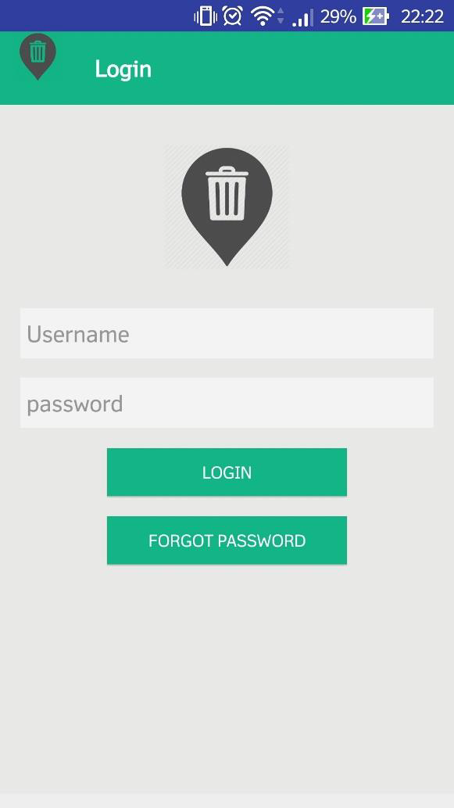

Login

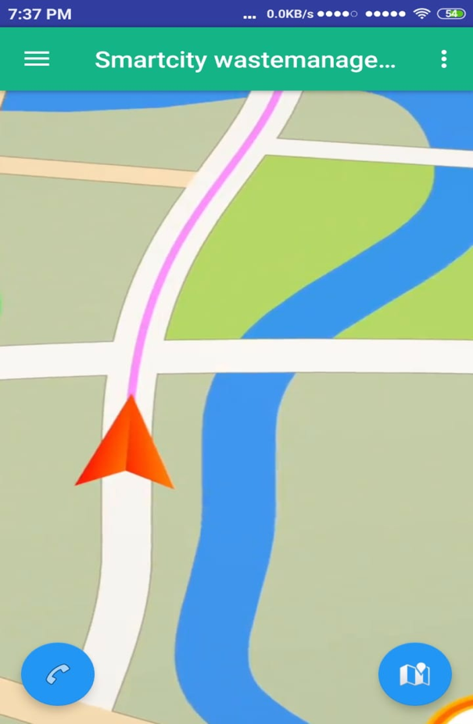

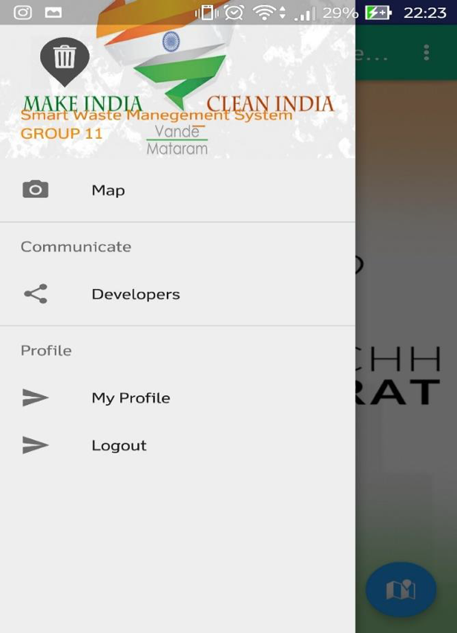

Home And Navigation

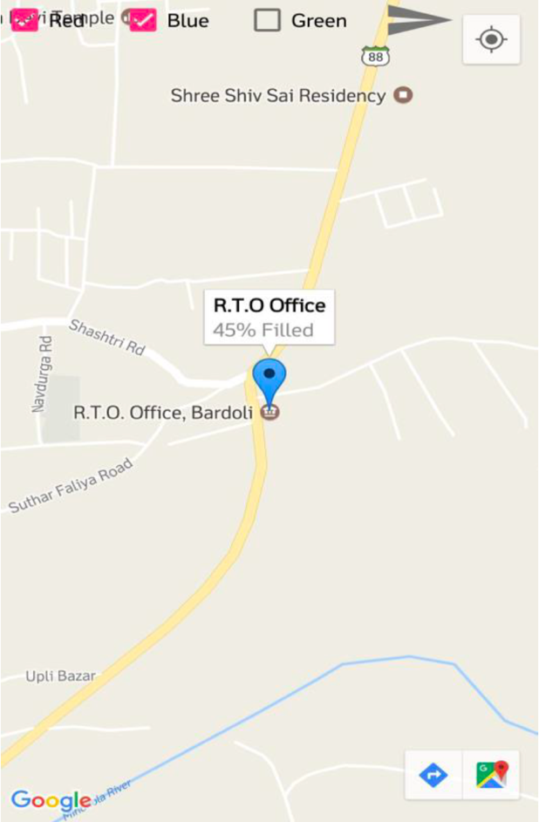

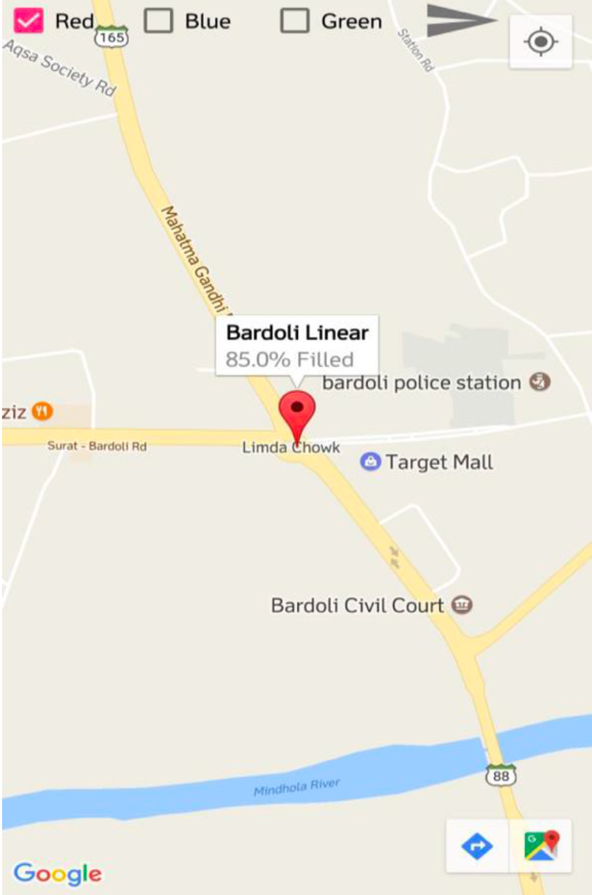

Status Of Dustbin

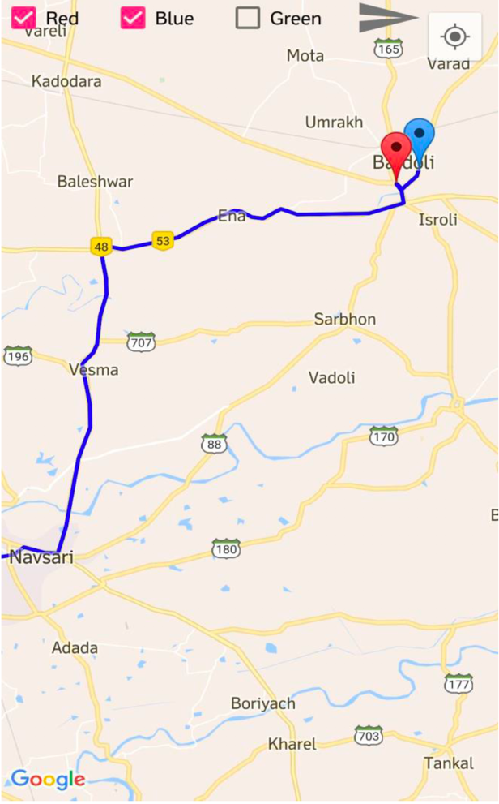

Minimized Route